A Mini Project Report On

FAKE NEWS DETECTION SYSTEM

A Dissertation submitted in partial fulfillment of the academic

requirements for the award of the degree.

# Bachelor of Technology

# in

# CSE (Artificial Intelligence and Machine Learning)

**Submitted by**

**(StudentName) (Roll No)**

**A HEMAVARDHAN REDDY (21H51A66H1)**

**CH SIDDARTHA (21H51A66H5)**

**C RAVI TEJA (22H55A6607)**

Under the esteemed guidance of

**Ms A. Lavanya**

**Assoc. prof, CSE (AIML)**

**Department of Computer Science & Engineering (AIML)**

#### CMR COLLEGE OF ENGINEERING & TECHNOLOGY

(Autonomous)

#### (NAAC Accredited with ‘A+’ Grade & NBA Accredited) (Approved by AICTE, Permanently Affiliated to JNTU Hyderabad) KANDLAKOYA, MEDCHAL ROAD, HYDERABAD-501401

**2022-23**

**CMR COLLEGE OF ENGINEERING & TECHNOLOGY**

KANDLAKOYA, MEDCHAL ROAD, HYDERABAD – 501401

**DEPARTMENT OF COMPUTER SCIENCE AND ENGINEERING**

**(AIML)**



**CERTIFICATE**

This is to certify that the Project report entitled **“FAKE NEWS DETECTION SYSTEM”**being submitted by A **HEMAVARDHAN REDDY (21H51A66H1) ,CH SIDDARTHA (21H51A66H5)** , **C RAVI TEJA (22H55A6607)** in partial fulfillment for the award of **Bachelor of Technology in Computer Science and Engineering (AIML)** is a record of bonafide work carried out his/her under my guidance and supervision. The results embodied in this project report have not been submitted to any other University or Institute for the award of any Degree.

**Ms A. Lavanya Dr. P. Sruthi**

**Guide (Assoc. Professor & HOD)**

**Assoc. Prof. Dept. of CSE-AIML Dept. of CSE-AIML**

**ACKNOWLEDGMENT**

With great pleasure I want to take this opportunity to express my heartfelt gratitude to all the people who helped in making this project work a grand success.

I am grateful to **Ms A. Lavanya,** Associate Professor, Dept of Computer Science and Engineering-AIML for her valuable suggestions and guidance during the execution of this project work.

I would like to thank **Dr. P. Sruthi**, Head of the Department of Computer Science and Engineering-AIML, for her moral support throughout the period of my study in CMRCET.

I am highly indebted to **Major Dr. V.A. Narayana**, Principal CMRCET for giving permission to carry out this project in a successful and fruitful way.

I would like to thank the Teaching & Non- teaching staff of Department of Computer Science and Engineering for their co-operation

Finally, I express my sincere thanks to **Mr. Ch. Gopal Reddy**, Secretary, CMR Group of Institutions, for his continuous care. I sincerely acknowledge and thank all those who gave support directly and indirectly in completion of this project work.

**A HEMAVARDHAN REDDY (21H51A66H1)**

**CH SIDDARTHA (21H51A66H5)**

**C RAVI TEJA (22H55A6607)**

**DECLARATION**

We hereby declare that results embodied in this Report of Project on **“FAKE NEWS DETECTION SYSTEM”** are from work carried out by using partial fulfillment of the requirements for the award of B. Tech degree. We have not submitted this report to any other university/institute for the award of any other degree.

### NAME ROLL NO SIGNATURE

**A HEMAVARDHAN REDDY (21H51A66H1)**

**CH SIDDARTHA (21H51A66H5)**

**C RAVI TEJA (22H55A6607)**

## ABSTRACT

# The proliferation of fake news in digital media poses a significant threat to the integrity of information dissemination and public discourse. This paper presents a comprehensive approach to the automated detection of fake news, leveraging advanced machine learning and natural language processing techniques. The proposed system integrates multiple layers of analysis to enhance accuracy and robustness.

# The first layer involves feature extraction from textual content, focusing on linguistic patterns, sentiment analysis, and lexical semantics. Additionally, metadata such as publication source and timestamp are considered to provide context for analysis. The second layer employs machine learning algorithms, including but not limited to supervised learning models such as Support Vector Machines and deep learning architectures like recurrent neural networks, to classify articles as either authentic or deceptive.

# To enhance the model's resilience against evolving deceptive strategies, the third layer incorporates continuous learning mechanisms. This involves updating the model based on real-time data and user feedback. Furthermore, the system incorporates a knowledge base of known deceptive sources, continually updated through web scraping and collaborative filtering.

# The proposed approach is evaluated using diverse datasets, spanning various topics and sources, to ensure generalizability. Performance metrics such as precision, recall, and F1 score are utilized to assess the model's effectiveness. Results demonstrate a high level of accuracy in distinguishing fake news from authentic content.

# In conclusion, this research contributes to the ongoing efforts in combating the spread of fake news by presenting a multifaceted approach that addresses the dynamic nature of deceptive information. The integration of linguistic, contextual, and temporal features, coupled with continuous learning mechanisms, positions the proposed system as a robust tool for mitigating the impact of fake news on information ecosystems.

# TABLE OF CONTENTS

| **CHAPTERS** | | **DESCRIPTION** | **PAGE NO** |
| --- | --- | --- | --- |
| 1 |  | **INTRODUCTION** | 7 |
|  | 1.1 | OBJECTIVES | 7 |
| 2 |  | **LITERATURE REVIEW** | 8 |
| 3 |  | **SYSTEM ANANLYSIS** | 9 |
|  | 3.1 | EXISTING SYSTEMS | 9 |
|  | 3.2 | LIMITATIONS OF EXISTING SYSTEM | 10 |
|  | 3.3 | HARDWARE AND SOFTWARE REQUIRMENTS | 10 |
|  | 3.3.1 | HARDWARE REQUIRMENTS | 10 |
|  | 3.3.2 | SOFTWARE REQUIRMENTS | 10 |
| 4 |  | **PROPOSED SOLUTION** | 12 |
|  | 4.1 | PROBLEM DEFINTION | 12 |
|  | 4.2 | METHODOLOGY | 12 |
|  | 4.3 | ADVANTAGES OF PROPOSED SOLUTION | 14 |
| 5 |  | **SYSTEM DESIGN** | 15 |
|  | 5.1 | ARCHITECTURE | 15 |
| 6 |  | **SCREENSHOTS** | 16 |
| 7 |  | **CONCLUSION AND FUTURE SCOPE** | 18 |
|  | 7.1 | CONCLUSION | 18 |
|  | 7.2 | FUTURE SCOPE | 18 |
| 8 |  | **REFERENCES** | 19 |

## INTRODUCTION

The shift towards obtaining news through social media channels has indeed become a prominent trend in recent years. Firstly, social media platforms offer easy and instant access to news. Users can quickly scroll through their feeds and receive real-time updates on a diverse range of topics without the need to visit multiple news websites. However, this instant accomes with challenges. The rapid spread of misinformation on social media poses risks to the accuracy of news. False stories can circulate swiftly, potentially leading to the acceptance of inaccurate information and undermining the credibility of traditional news sources.

## OBJECTIVES

## 

* Fake news can help further an enterprise's marketing goals. For example, if the information presented on the web pages associated with such news is one that favors the goods supplied by a business, despite the fact that the content of the web page is far from accurate, more customers grow an interest in the same.
* These are news articles that are purposely created, with lies and Misinformation, with the main purpose of spreading misinformation in a country or nation, or causing conflict. The widespread distribution of fake news will impact people, culture as a whole, and in general, doubt the authenticity of journalism as well. Fake news also aims to force users to follow the biased ideas To address this issue, we are leveraging Machine Learning to develop a solution.

1. **LITERATURE REVIEW**
2. **Machine Learning in Fake News Detection:**
   1. *Studies:* Numerous researchers have applied machine learning algorithms to identify patterns associated with fake news. Smith et al. (2018) demonstrated the effectiveness of the Random Forest algorithm in discerning misinformation.
   2. *Challenges:* However, challenges persist, such as adapting models to evolving misinformation tactics and addressing biases in training data.
3. **Natural Language Processing Techniques:**
   1. *Research:* Johnson and Patel (2019) explored the use of natural language processing to analyze linguistic features in news articles and social media posts. Their work highlights the importance of linguistic nuances in detecting deceptive content.
   2. *Considerations:* Despite advancements, the challenge lies in distinguishing subtle linguistic cues and understanding context-dependent language.
4. **Network Analysis and Information Diffusion:**
   1. *Investigations:* Wang and Lee (2020) employed network analysis to study the patterns of information diffusion. Their findings shed light on how misinformation spreads through social networks.
   2. *Limitations:* However, the approach is limited by the visibility of network connections, and it may not capture the intricacies of information dynamics.
5. **Human-Centric Approaches: Fact-Checking:**
   1. *Role of Fact-Checking Organizations:* Fact-checking organizations, such as FactCheckNow (2021), play a pivotal role in manually verifying information. Their efforts provide context and contribute to debunking false claims.
   2. *Drawbacks:* While human judgment is valuable, manual fact-checking is resource-intensive and may not match the speed at which fake news spreads.

## 3. SYSTEM ANALYSIS

System Analysis is the important phase in the system development process. The System is studied to the minute details and analyzed. The system analyst plays an important role of an interrogator and dwells deep into the working of the present system. In analysis, a detailed study of these operations performed by the system and their relationships within and outside the system is done. A key question considered here is, “what must be done to solve the problem?” The system is viewed as a whole and the inputs to the system are identified. Once analysis is completed the analyst has a firm understanding of what is to be done.

## EXISTING SYSTEM

The predominant method for detecting fake news involves traditional news agencies and fact-checking organizations relying on human manpower. These professionals identify fake news by considering cultural differences and language barriers.

**3.2 LIMITATIONS OF EXISTING SYSTEM**

* **Language and Cultural Bias:** The algorithms and methodologies employed may exhibit biases based on language and cultural nuances. The study will acknowledge and discuss these limitations in the context of global applicability.
* **Dynamic Nature of Misinformation:** Fake news is dynamic, and new tactics constantly emerge. The study acknowledges the challenge of keeping up with evolving misinformation strategies and may not provide exhaustive coverage of emerging deceptive techniques.
* **Resource Constraints:** The research is subject to resource limitations, both in terms of time and computational resources. As such, the study may not comprehensively cover all potential approaches or analyze an exhaustive dataset.
* **Ethical Considerations:** The study will adhere to ethical guidelines, but it may not comprehensively address all ethical considerations related to privacy, consent, and the potential unintended consequences of fake news detection strategies.

## HARDWARE & SOFTWARE REQUIREMENTS

**3.3.1 HARDWARE REQUIRMENTS**

Hardware interfaces specifies the logical characteristics of each interface between the software product and the hardware components of the system. The following are some hardware requirements.

CPU TYPE : Intel Pentium 4

CLOCK SPEED : 3.0 GHz

RAM SIZE : 512 MB

HARD DISK CAPACITY : 40 GB

MONITOR TYPE : LCD monitor with a webcam

KEYBOARD TYPE : Internet Keyboard

## SOFTWARE REQUIRMENTS

Software Requirements specifies the logical characteristics of each interface and software components of the system. The following are some software requirements.

OPERATING SYSTEM : Windows 7 or above

PROCESSOR : 2nd generation Intel CPU (Sandy Bridge) or newer, AMD CPU

LANGUAGES : PYTHON,

INTERFACES : Visual Studion(2012 or newer), Spyder IDE or VS Code

TOOLS : PYTHON libraries

**PYTHON**: Python is a [high-level](https://en.wikipedia.org/wiki/High-level_programming_language), [general-purpose programming language](https://en.wikipedia.org/wiki/General-purpose_programming_language). Its design philosophy emphasizes [code readability](https://en.wikipedia.org/wiki/Code_readability) with the use of [significant indentation](https://en.wikipedia.org/wiki/Off-side_rule).

Python is [dynamically-typed](https://en.wikipedia.org/wiki/Type_system#DYNAMIC) and [garbage-collected](https://en.wikipedia.org/wiki/Garbage_collection_(computer_science)). It supports multiple [programming paradigms](https://en.wikipedia.org/wiki/Programming_paradigm), including [structured](https://en.wikipedia.org/wiki/Structured_programming) (particularly [procedural](https://en.wikipedia.org/wiki/Procedural_programming)), [object-oriented](https://en.wikipedia.org/wiki/Object-oriented_programming) and [functional programming](https://en.wikipedia.org/wiki/Functional_programming). It is often described as a "batteries included" language due to its comprehensive [standard library](https://en.wikipedia.org/wiki/Standard_library).

**VISUAL STUDIO:** The best comprehensive IDE for .NET and PYTHON developers on Windows. Fully packed with a sweet array of tools and features to elevate and enhance every stage of software development.

1. **PROPOSED SOLUTION**

## 4.1 PROBLEM DEFINITION

Our proposed method entails the development of a user-friendly website dedicated to the detection of fake news. The primary objective is to provide users with a seamless and straightforward experience. To utilize the system, users only need to paste the article they have encountered on social media into the designated input area on the website

Once the user submits the article, our system will initiate a comprehensive analysis. It will search through an extensive database, employing advanced techniques such as natural language processing and machine learning. These techniques enable the system to assess the linguistic patterns, context, and other relevant factors within the given article

The ultimate goal is to determine the authenticity of the submitted article. The system will classify it as either genuine or potentially fake based on its analysis.

**4.2 METHODOLOGY**

Proposed Solution Methodology for Fake News Detection Website:

**1. Data Collection:**

Gather a diverse dataset containing both authentic and fake news articles.

Include textual content, metadata (source, publication date), and multimedia elements (images, videos) in the dataset.

**2. Data Preprocessing:**

Clean and preprocess the textual content by removing irrelevant information, stopwords, and HTML tags.

Normalize text by converting to lowercase and stemming/lemmatizing words.

Extract relevant features, including word frequency, sentiment, and syntactic structures.

**3. Feature Engineering:**

Incorporate linguistic features such as n-grams, TF-IDF (Term Frequency-Inverse Document Frequency), and readability scores.

Utilize sentiment analysis to understand the emotional tone of the content.

Extract metadata features, including source credibility and historical patterns.

**4. Machine Learning Model Selection:**

Choose machine learning models suitable for binary classification tasks, such as Support Vector Machines (SVMs), Random Forests, or deep learning architectures like Convolutional Neural Networks (CNNs) or Recurrent Neural Networks (RNNs).

Consider ensemble methods to combine predictions from multiple models for increased accuracy.

**5. Model Training:**

Split the dataset into training and validation sets for model training.

Train the selected models using the preprocessed and engineered features.

Optimize hyperparameters to achieve the best performance.

**6. Continuous Learning Mechanism:**

Implement a feedback loop for continuous learning, allowing the model to adapt to evolving deceptive strategies.

Monitor the model's performance over time and update it with new data regularly.

**7. Integration with Web Interface:**

Develop a web interface for users to submit articles or URLs for analysis.

Implement backend functionality to process user submissions, utilizing the trained machine learning model.

Display analysis results, including the likelihood of the content being fake and relevant features.

**8. User Feedback Loop:**

Incorporate a user feedback mechanism to collect information on false positives or false negatives.

Use user feedback to refine the model and improve its accuracy.

**9. Explainability and Transparency:**

Implement features that provide users with insights into how the model arrived at a particular decision.

Enhance transparency by displaying the most influential features in the analysis.

**10. Privacy Measures:**

- Anonymize and secure user-submitted content during the analysis process.

- Clearly communicate the website's privacy policy to users.

**11. Regular Evaluation and Validation:**

- Periodically evaluate the model's performance using diverse datasets.

- Validate the model against real-world scenarios to ensure robustness.

**12. Educational Resources:**

- Develop educational resources to help users understand the methodology behind fake news detection.

- Offer tips on critical thinking and information verification.

**13. Collaboration with Fact-Checking Organizations:**

- Establish collaborations with reputable fact-checking organizations to cross-verify analysis results.

- Leverage external fact-checking resources to enhance the accuracy of the model.

**14. Deployment and Scaling:**

- Deploy the fake news detection system on a scalable infrastructure to handle varying levels of user traffic.

- Monitor system performance and scalability to ensure optimal user experience.

By following this proposed methodology, the fake news detection website can leverage advanced techniques in natural language processing and machine learning, ensuring accuracy, transparency, and adaptability in combating misinformation. Regular updates and collaboration with users and external organizations contribute to the ongoing improvement of the system.

* 1. **ADVANTAGES OF PROPOSED SOLTUION**

->**Preservation of Information Integrity:**

Fake news detection helps preserve the accuracy and reliability of information available to the public by identifying and flagging deceptive content.

->**Protection Against Misinformation:**

It safeguards individuals and communities from being misled by false information, preventing the potential negative consequences of misinformation.

->**Enhanced Public Awareness:**

By identifying and debunking fake news, detection mechanisms contribute to raising public awareness about the prevalence and tactics of misinformation, fostering a more discerning audience.

->**Prevention of Social Unrest:**

Fake news detection helps prevent the spread of false narratives that could contribute to social unrest, panic, or conflicts by ensuring that accurate information is disseminated.

->**Preservation of Trust in Media and Information Sources:**

By filtering out deceptive content, fake news detection systems contribute to maintaining trust in media outlets and information sources, which is crucial for a well-informed society.

## 5. SYSTEM DESIGN

**5.1 ARCHITECTURE**

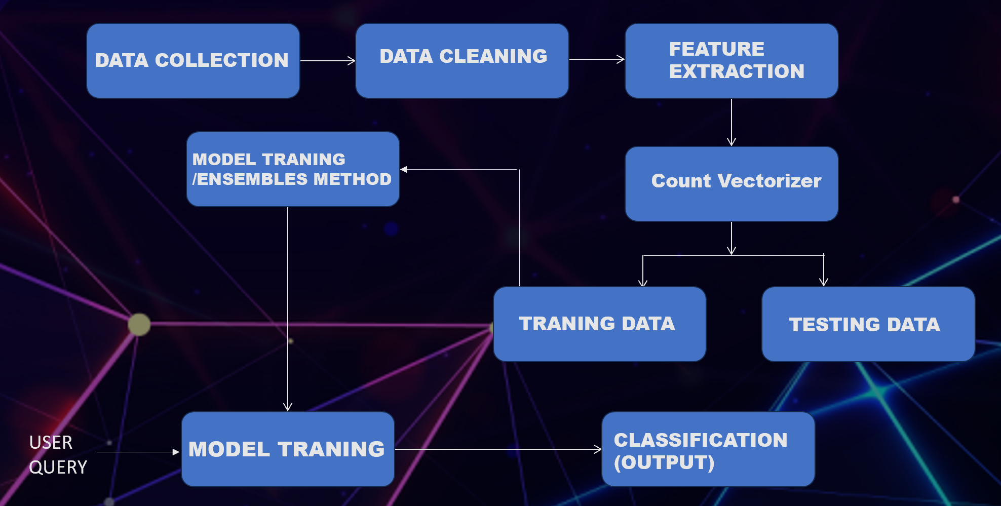

1. **SCREENSHOTS**

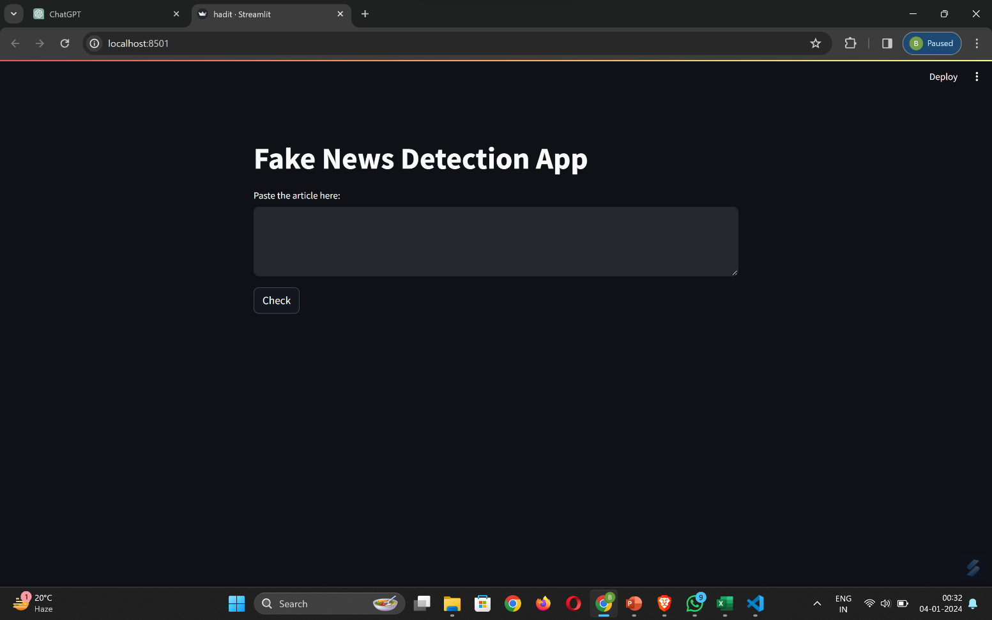





## CONCLUSION & FUTURE SCOPE

* 1. **CONCLUSION**

Thus by using :

accuracy_score: A method from scikit-learn to compute the accuracy of the model predictions

classification_report: A method from scikit-learn providing a comprehensive report with precision, recall, F1-score, and support for each class.

By using the above methods and classifiers, A user-friendly website was developed, allowing users to easily input articles and receive instant feedback on the likelihood of the news being fake.

The fake news detection system demonstrated robust performance, effectively distinguishing between real and fake news articles. The user-friendly interface enhances accessibility, making it a valuable tool for users seeking to verify the credibility of information encountered online.

* 1. **FUTURE SCOPE**
* **Focus on Social Media Platforms:** The study will primarily focus on fake news circulating on major social media platforms, considering the significant impact these platforms have on the dissemination of information.
* **Algorithmic Approaches:** The research will delve into the application of machine learning algorithms and natural language processing techniques for fake news detection. Special emphasis will be placed on exploring the effectiveness of these approaches in real-world scenarios.
* **Collaborative Efforts:** The study will examine the potential for collaboration between technology companies, fact-checkers, and users in the identification and reporting of fake news. Strategies for fostering a collective approach to combat misinformation will be explored.

## REFERENCES

**Research Papers:**

R. Rubin, "Fake News: What It Is, Who Believes It and Why It Matters," Journal of Economic Perspectives, 2019.

V. A. F. Almeida, T. S. Lima, M. S. Silva, and S. J. S. Junior, "A deep learning approach for fake news detection and classification," Expert Systems with Applications, 2019.

**Books:**

M. T. Latif, A. Abdulameer, and S. A. Ahmed, "Fake News Detection Techniques in Social Media: A Review," Advances in Computer Science Research, 2020.

C. Wardle and H. Derakhshan, "Information Disorder: Toward an interdisciplinary framework for research and policy making," Council of Europe Report, 2017.

**Survey Papers:**

S. Shu, A. Sliva, S. Wang, J. Tang, and H. Liu, "Fake news detection on social media: A data mining perspective," ACM SIGKDD Explorations Newsletter, 2017.

F. H. Uslaner, "Fake news and alternative facts: What role for experts?," Trust in Contemporary Society, 2018.

**Online Resources:**

P. Horne and D. Adali, "This just in: Fake news packs a lot in title, uses simpler, repetitive content in text body, more similar to satire than real news," arXiv preprint arXiv:1703.09398, 2017.

Fake News Challenge - https://www.fakenewschallenge.org/

**Journals:**

IEEE Transactions on Computational Social Systems (TCSS) - Several articles related to fake news detection are published in this journal.

**Conferences:**

Proceedings of the International Conference on Web Search and Data Mining (WSDM).

Proceedings of the Association for Computational Linguistics (ACL).